**BANK LOAN REPORT QUERY DOCUMENT**

1. **BANK LOAN REPORT | SUMMARY**

KPI’s:

Total Loan Applications:

1. select count(id) as Total_Loan_Applications from bank_loan_data



MTD Loan Applications:

1. select count(id) as MTD_Total_Loan_Applications from bank_loan_data

where month(issue_date) = 12 and year(issue_date) = 2021



PMTD Loan Applications:

1. select count(id) as PMTD_Total_Loan_Applications from bank_loan_data

where month(issue_date) = 11 and year(issue_date) = 2021



Total Funded Amount:

1. select sum(loan_amount) as Total_Funded_Amount from bank_loan_data



MTD Total Funded Amount:

1. select sum(loan_amount) as MTD_Total_Funded_Amount from bank_loan_data

where month(issue_date) = 12 and year(issue_date) = 2021



PMTD Total Funded Amount:

1. select sum(loan_amount) as PMTD_Total_Funded_Amount from bank_loan_data

where month(issue_date) = 11 and year(issue_date) = 2021



Total Amount Received:

1. select sum(total_payment) as Total_Amount_Received from bank_loan_data



MTD Total Amount Received:

1. select sum(total_payment) as MTD_Total_Amount_Received from bank_loan_data

where month(issue_date) = 12 and year(issue_date) = 2021



PMTD Total Amount Received:

1. select sum(total_payment) as PMTD_Total_Amount_Received from bank_loan_data

where month(issue_date) = 11 and year(issue_date) = 2021



Average Interest Rate:

1. select avg(int_rate) * 100 as Average_Interest_Rate from bank_loan_data



MTD Average Interest Rate:

1. select round(avg(int_rate), 4) * 100 as MTD_Average_Interest_Rate from bank_loan_data

where month(issue_date) = 12 and year(issue_date) = 2021



PMTD Average Interest Rate:

1. select round(avg(int_rate), 4) * 100 as PMTD_Average_Interest_Rate from bank_loan_data

where month(issue_date) = 11 and year(issue_date) = 2021



AVG DTI:

1. select round(avg(dti), 4) * 100 as Avg_DTI from bank_loan_data



MTD AVG DTI:

1. select round(avg(dti), 4) * 100 as MTD_Avg_DTI from bank_loan_data

where month(issue_date) = 12 and year(issue_date) = 2021



PMTD AVG DTI:

1. select round(avg(dti), 4) * 100 as PMTD_Avg_DTI from bank_loan_data

where month(issue_date) = 11 and year(issue_date) = 2021



GOOD LOAN ISSUED

Good Loan Percentage:

1. select (count(case when loan_status = 'Fully Paid' or loan_status = 'Current' then id end) * 100)

/

count(id) as Good_Loan_Percentage

from bank_loan_data



Good Loan Applications:

1. select count(id) as Good_Loan_Application from bank_loan_data

where loan_status = 'Fully Paid' or loan_status = 'Current'



Good Loan Funded Amount:

1. select sum(loan_amount) as Good_Loan_Funded_Amount from bank_loan_data

where loan_status = 'Fully Paid' or loan_status = 'Current'

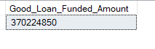

Good Loan Amount Received:

1. select sum(total_payment) as Good_Loan_Amount_Received from bank_loan_data

where loan_status = 'Fully Paid' or loan_status = 'Current'

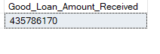

BAD LOAN ISSUED

Bad Loan Percentage:

1. select (count(case when loan_status = 'Charged Off' then id end) * 100.0) /

count(id) as Bad_Loan_Percentage from bank_loan_data



Bad Loan Application:

1. select count(id) as Bad_Loan_Application from bank_loan_data

where loan_status = 'Charged Off'

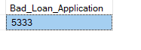

Bad Loan Funded Amount:

1. select sum(loan_amount) as Bad_Loan_Funded_Amount from bank_loan_data

where loan_status = 'Charged Off'



Bad Loan Amount Received:

1. select sum(total_payment) as Bad_Loan_Amount_Received from bank_loan_data

where loan_status = 'Charged Off'



Loan Status

select

loan_status,

count(id) as Total_Loan_Applications,

sum(total_payment) as Total_Amount_Received,

sum(loan_amount) as Total_Funded_Amount,

avg(int_rate * 100) as Interest_Rate,

avg(dti * 100) as DTI

from

bank_loan_data

group by loan_status

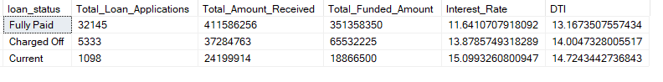

1. select

loan_status,

sum(total_payment) as MTD_Total_Amount_Received,

sum(loan_amount) as MTD_Total_Funded_Amount

from bank_loan_data

where month(issue_date) = 12

group by loan_status

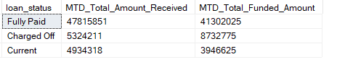

MONTH

select

month(issue_date) as month_number,

DATENAME(month, issue_date) as month_name,

count(id) as Total_Loan_Applications,

sum(loan_amount) as Total_Funded_Amount,

sum(total_payment) as Total_Amount_Received

from bank_loan_data

group by month(issue_date) , DATENAME(month, issue_date)

order by month(issue_date)

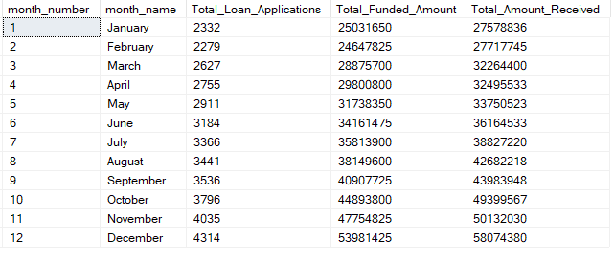

Regional

select

address_state,

count(id) as Total_Loan_Applications,

sum(loan_amount) as Total_Funded_Amount,

sum(total_payment) as Total_Amount_Received

from bank_loan_data

group by address_state

order by count(id) desc

(First 16 rows ss)

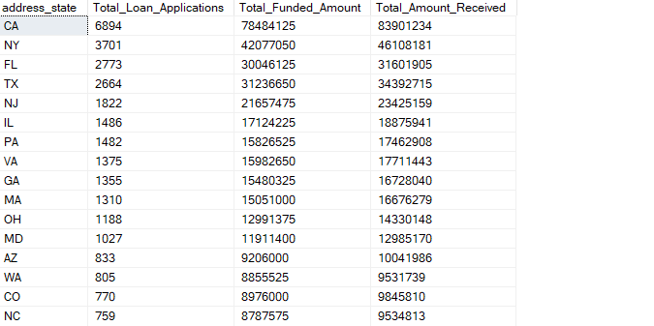

TERM

1. select

term,

count(id) as Total_Loan_Applications,

sum(loan_amount) as Total_Funded_Amount,

sum(total_payment) as Total_Amount_Received

from bank_loan_data

group by term

order by term

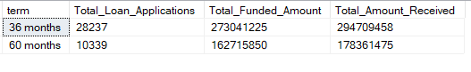

EMP_LENGTH

1. select

emp_length,

count(id) as Total_Loan_Applications,

sum(loan_amount) as Total_Funded_Amount,

sum(total_payment) as Total_Amount_Received

from bank_loan_data

group by emp_length

order by count(id) desc

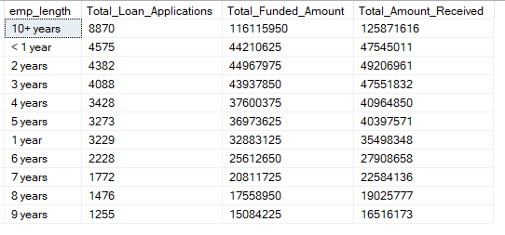

LOAN PURPOSE

1. select

purpose,

count(id) as Total_Loan_Applications,

sum(loan_amount) as Total_Funded_Amount,

sum(total_payment) as Total_Amount_Received

from bank_loan_data

group by purpose

order by count(id) desc

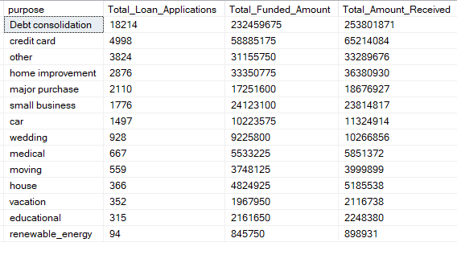

HOME OWNERSHIP

1. select

home_ownership,

count(id) as Total_Loan_Applications,

sum(loan_amount) as Total_Funded_Amount,

sum(total_payment) as Total_Amount_Received

from bank_loan_data

group by home_ownership

order by count(id) desc

